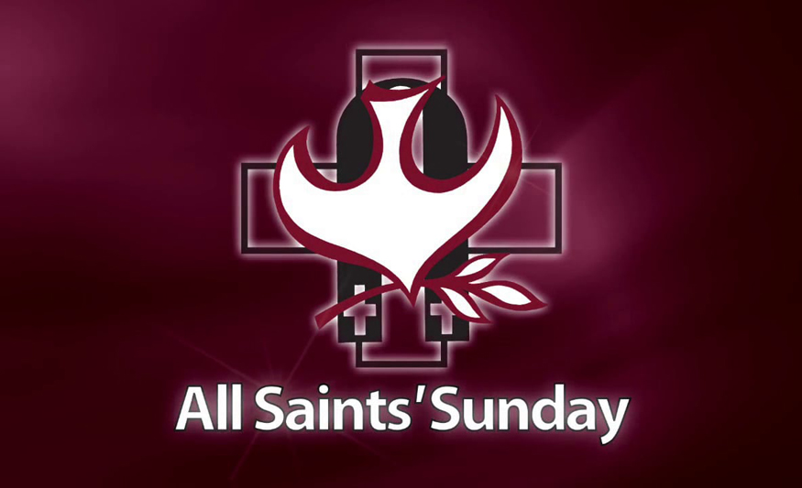
Feast of All Saints

1st Reading: Revelation 7:2-4, 9-14
Vast numbers were sealed with the sign of the Living God
I saw another angel ascending from the rising of the sun, having the seal of the living God, and he called with a loud voice to the four angels who had been given power to damage earth and sea, saying, “Do not damage the earth or the sea or the trees, until we have marked the servants of our God with a seal on their foreheads.” And I heard the number of those who were sealed, one hundred forty-four thousand, sealed out of every tribe of the people of Israel.
After this I looked, and there was a great multitude that no one could count, from every nation, from all tribes and peoples and languages, standing before the throne and before the Lamb, robed in white, with palm branches in their hands. They cried out in a loud voice, saying, “Salvation belongs to our God who is seated on the throne, and to the Lamb!” And all the angels stood around the throne and around the elders and the four living creatures, and they fell on their faces before the throne and worshiped God, singing, “Amen! Blessing and glory and wisdom and thanksgiving and honour and power and might be to our God forever and ever! Amen.” Then one of the elders addressed me, saying, “Who are these, robed in white, and where have they come from?” I said to him, “Sir, you are the one that knows.” Then he said to me, “These are they who have come out of the great ordeal; they have washed their robes and made them white in the blood of the Lamb.

Responsorial: Psalm 24
Response: Lord, these are the people that longs to see your face
The Lord’s is the earth and its fullness,
the world, and those who dwell in it.
It is he who set it on the seas;
on the rivers he made it firm. Resp:
Who shall climb the mountain of the Lord?
Who shall stand in his holy place?
The clean of hands and pure of heart,
whose soul is not set on vain things. Resp:
Blessings from the Lord shall they receive,
and right reward from the God who saves them.
Such are the people who seek him,
who seek the face of the God of Jacob. Resp:

2nd Reading: 1 John 3:1-3
The love the Father has given us, that we should be called children of God
See what love the Father has given us, that we should be called children of God; and that is what we are. The reason the world does not know us is that it did not know him. Beloved, we are God’s children now; what we will be has not yet been revealed. What we do know is this: when he is revealed, we will be like him, for we will see him as he is. And all who have this hope in him purify themselves, just as he is pure.
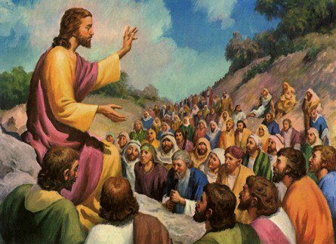

Gospel: Matthew 5:1-12
The Beatitudes as guide to the Kingdom of Heaven
When Jesus saw the crowds, he went up the mountain; and after he sat down, his disciples came to him. Then he began to speak, and taught them, saying:
“Blessed are the poor in spirit, for theirs is the kingdom of heaven.
“Blessed are those who mourn, for they will be comforted.
“Blessed are the meek, for they will inherit the earth.
“Blessed are those who hunger and thirst for righteousness, for they will be filled.
“Blessed are the merciful, for they will receive mercy.
“Blessed are the pure in heart, for they will see God.
“Blessed are the peacemakers, for they will be called children of God.
“Blessed are those who are persecuted for righteousness’ sake,
for theirs is the kingdom of heaven.
“Blessed are you when people revile you and persecute you and utter all kinds of evil against you falsely on my account. Rejoice and be glad, for your reward is great in heaven, for in the same way they persecuted the prophets who were before you.”
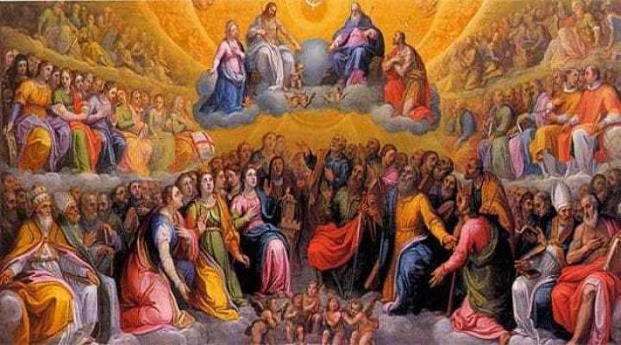

Reflections:
A veil of mystery hides what lies in store for human beings beyond this mortal life here and now. Saint Paul recognises this fact when he says that “No eye has seen, no ear has heard nor has it entered the human heart to imagine what God has prepared for those who love him.” (1 Cor 2:9). Still, the holy Scriptures provide a wealth of hopeful images to give a foretaste of what lies in store beyond this world, for those who love God. Those in heaven are no plaster saints, no gloomy killjoys, but a glorious band of decent people who lived with such love, they went straight back to the God they loved so well. They went “marching in” — happy to be meeting face to face with the One who always held them in the palm of his hand. Heroes and ordinary people. Some who have inspired the church for centuries, and other unsung heroes, living a quiet life of kindness and duty, pure of heart and gentle of spirit.
“A great multitude that no one could count” — because God is rich in mercy, and in the Father’s House there are many mansions. There’s place there for all of us, and the surest way is to cling to “the Way, the Truth and the Life.” Jesus has told how to be good people. He shows us how to be the best people we can be, and the qualities he wants to see in us, his followers. A quick focus on those qualities shows us that they are the very opposite of common and accepted standards and values: –
The world says, Blessed are the rich, because they can have anything they want. But Jesus says, Blessed are the poor in spirit. By poor in spirit he means those who put their trust in God rather than money; and those who admit that it is not their income, possessions or bank account that makes them rich in the eyes of God, but what kind of people they are.
The world says, Blessed are those who live it up, and never stop having fun. But Jesus says, Blessed are those who mourn. He means those who let themselves feel the misfortune, pain and sorrow of others, and who respond to them with understanding, sympathy, kindness, compassion, and practical assistance.
The world says, Blessed are the assertive and aggressive that talk tough and act tough. But Jesus says, Blessed are the gentle. Gentleness is not weakness, but a form of strength. St Francis de Sales used to say that you can catch more flies with a spoon full of sugar than a barrel full of vinegar. In Jesus’ book, there is just no place for bullies and bullying.
The world says, Blessed are those who hunger for power, status, and fame. But Jesus says, Blessed are those who hunger and thirst for what is right. The only power and status we really need is to keep living in God’s way and to keep doing the right thing. More satisfaction and contentment will be found in living with a good conscience than in hanging out with the movers and shakers and wannabes of this world.
The world says, Blessed are those who show no mercy and who take no prisoners. But Jesus says, Blessed are the merciful. Happy are those who make allowances for the faults and sins of others, and whose greatness lies in their ability to forgive. They will receive mercy and forgiveness from God for their own sins.
The world says, Happy are those with clean fingernails, sparkling eyes, gleaming teeth, and unblemished skin. But Jesus says, blessed are those with clean hearts. It’s from the heart that all our thoughts, words, and actions flow. If the heart is clean, then everything that flows from it will be clean, as clean as water flowing from an unpolluted spring.
The world says, Blessed are those who get even and exact revenge. But Jesus says, Blessed are the peacemakers. Happy are those who spread understanding among people, those who welcome strangers, and those who work for a more just and equal society. They are truly the children of God.
The world says, Blessed are those who lie and cheat and get away with it. But Jesus says, Blessed are those who make a stand for what is right and true. They may suffer for their stand, but the wounds they bear will be marks of honour and integrity. Jesus practised what he preached. In his own person he was the beatitudes. Living them day after day made him the thoroughly good person he was. It is the same for us too.
Today’s feast is not about the canonised saints but about all the good and holy people who have ever lived. None of us is expecting to be a canonised saint. We don’t fantasise that one day some pope will declare what saints we were. We don’t expect that our picture is going to be revered on the walls of churches. Not for a moment do we imagine anyone saying prayers to us or preserving pieces of us as relics. But in its document on the Church, the Second Vatican Council wrote a chapter called The Universal Call to Holiness. So our Feast today is reminding us of our deep-down calling to become better people than we currently are! It is reminding us that Jesus Christ can and will empower us to practise what he preached and to live what we believe! Surely, then, we won t ever want to stop receiving him as our Bread of Life in Holy Communion! Amen.
